


Version: 5.1.2
Published date: August 2026
Copyright © 2026 by ESW. All rights reserved. Information contained herein is subject to change without notice.

Checkout Shopper Registration INTEGRATION GUIDE

SFCC - ESW Cartridge
+
Contents
- Checkout Shoppers Registration 3
  - Benefits 3
  - Session Details 4
  - ESW Checkout Shopper integration Configuration site preferences 4
  - First-time Experience- New shoppers prompted to register account link redirects to write form 5
  - Repeat Shoppers Experience- Returning Shoppers are presented with the register account link redirects to login form 6
  - Testing Sandbox/Staging Environment 6

Checkout Shoppers Registration
  - Benefits
Following are some benefits of using the checkout shoppers’ registration feature.
- This ESW SFCC plugin allows for building up an international shoppers database.
- Offer international shoppers promotions based on their purchase history.
- Allow shoppers to track orders using the logged-in shopper’s dashboard.
- Conversion rate of existing customers will be higher due to saving time on checkout.
In addition to checkout shoppers’ registration, the Chances of winning retailers will increase by adding this feature.
How does this work?
The following diagram explains the workflow between the ESW-SFCC plugin/cartridge and ESW Checkout.
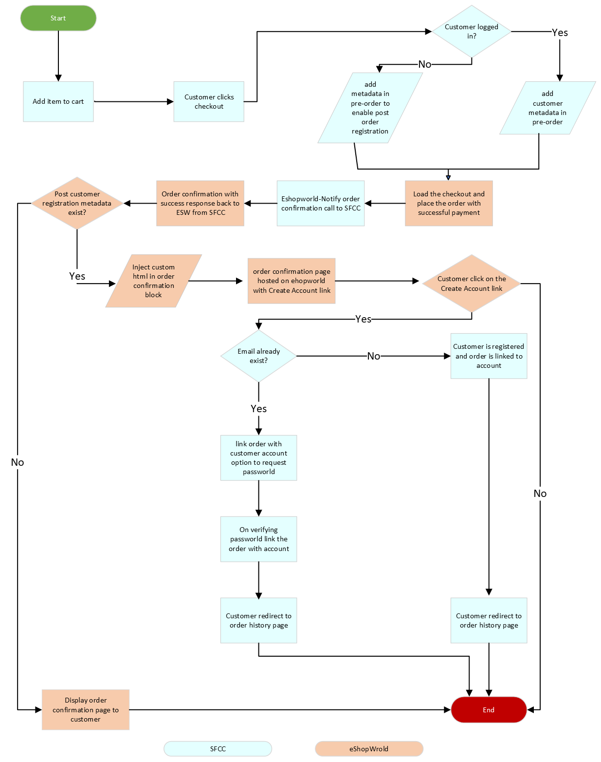
The following flow adds meta to pre-order based on the customer’s authentication to enable post-order registration.
- The shopper adds an item to the cart and clicks Checkout.

  - If the user is not logged in, add meta in the pre-order request to enable account registration post to order.
  - Store customer’s order number in session to access order later.
- ESW loads the checkout and places an order with successful payment after getting a confirmation from SFCC to ESW.
  - If the customer’s registration meta exists, ESW injects customer registration HTML in the order confirmation block and displays the account registration link on the order confirmation page.
  - If customer registration meta is not present, display the order confirmation page to the customer.

- On the ESW order confirmation page, once a customer clicks on create account link
  - If the customer’s account with the order email already exists in SFCC
- Render login form with pre-filled email.
- On form submit after verifying customer password link order with customer’s account.
  - If no account is present with the order email in SFCC
- Once the customer click on the create account link, register the customer’s account and link the order with the newly created account.
  - Session Details

The following session attribute is created to register new guest users after placing the order on ESW checkout. Newly placed orders are then linked to the newly registered user profile.
- Name: confirmedOrderID

- Non-Headless Architect – Session Attribute creation
Sitegenisis/SFRA storefront confirmation order session attribute is created on pre-order request.
- Non-Headless Architect – Session Attribute deletion
Sitegenisis/SFRA storefront confirmation order session attribute is deleted on successful account page landing.
  - ESW Checkout Shopper integration Configuration site preferences
You can use Custom Preferences to manage ESW-specific configurations of the cartridge. You can access Custom Preferences by navigating to Merchant Tools > Site Preferences > Custom Preferences > ESW Checkout Configuration.
The following option is present ESW Checkout Configuration group.
Enable ESW Checkout Shoppers Registration: To enable/disable the ESW checkout shopper registration option.

  - First-time Experience- New shoppers prompted to register account link redirects to order history page
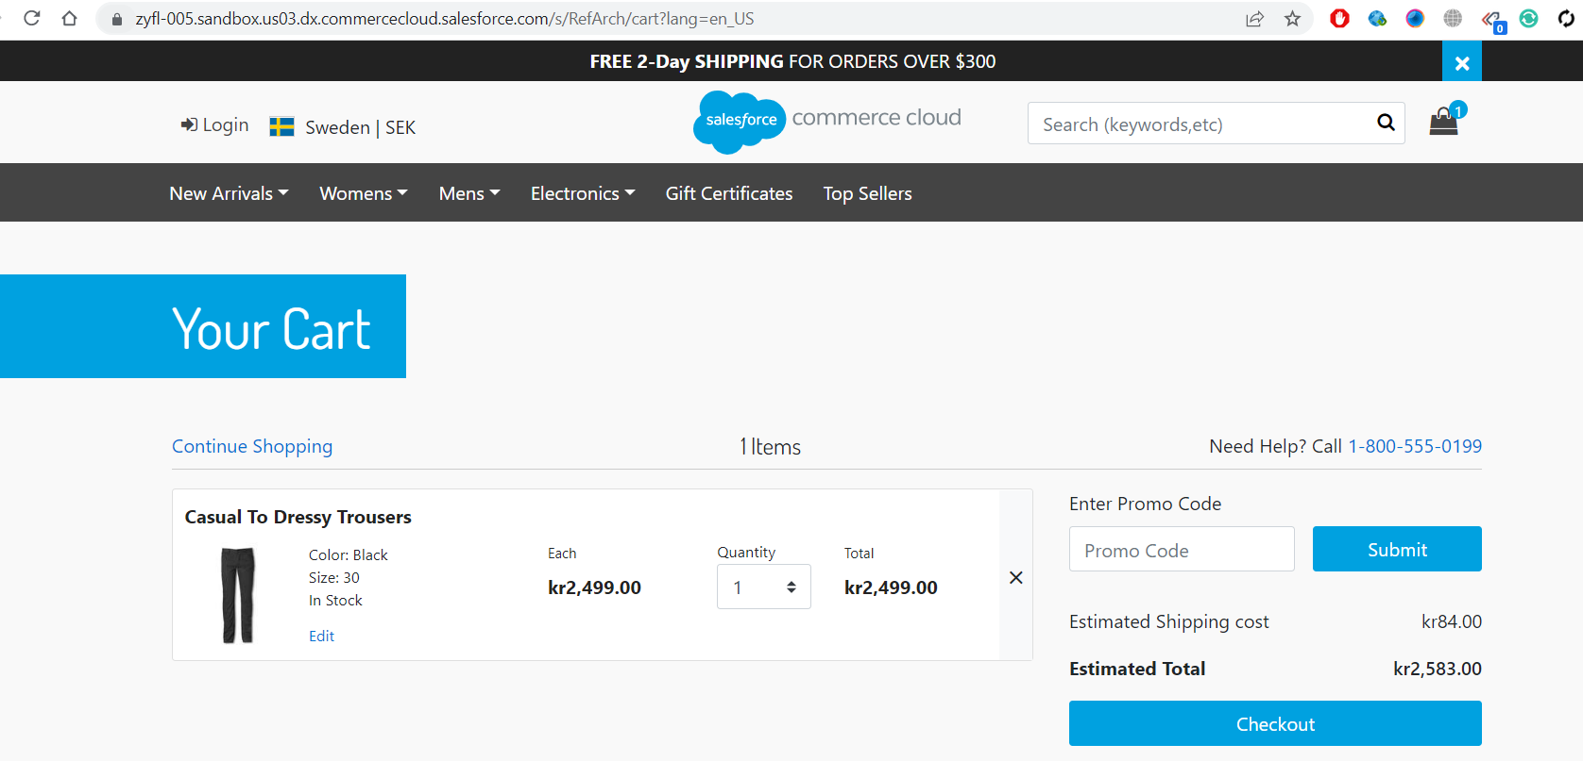

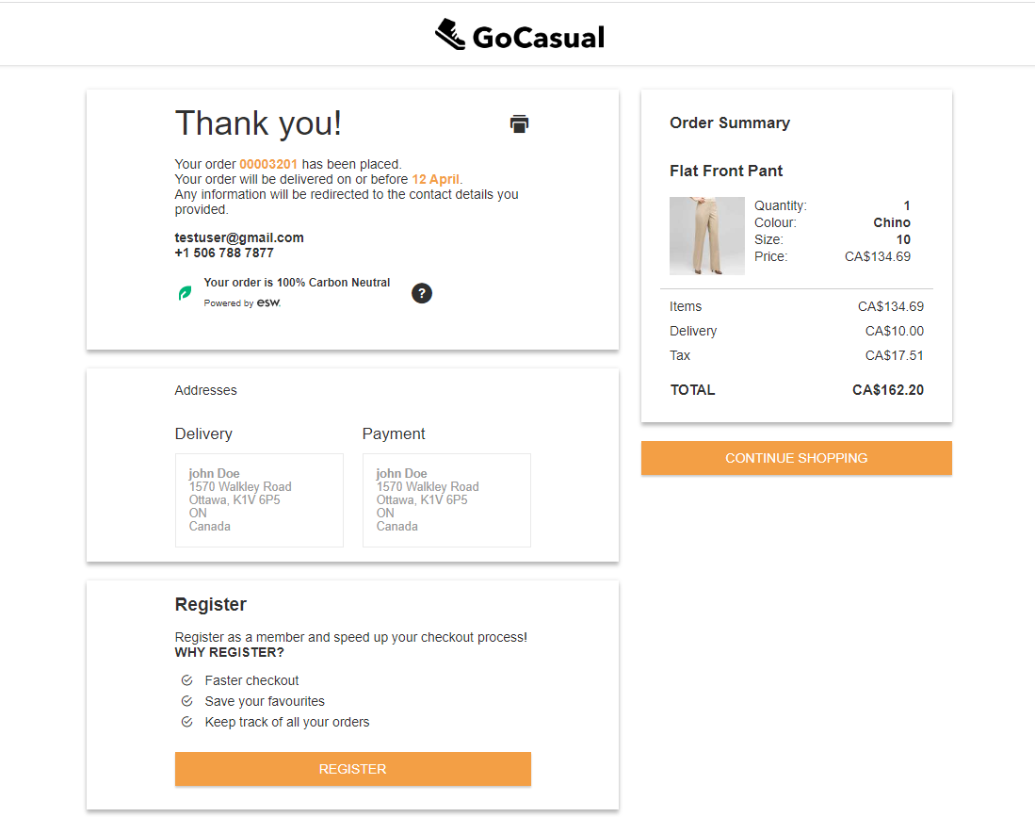

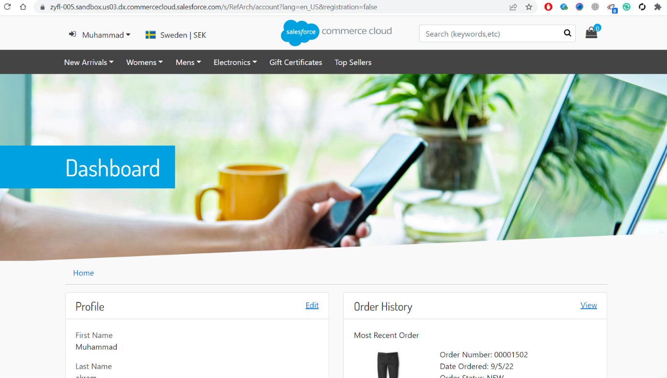

  - Repeat Shoppers Experience- Returning Shoppers are presented with the register account link that redirects to the login form

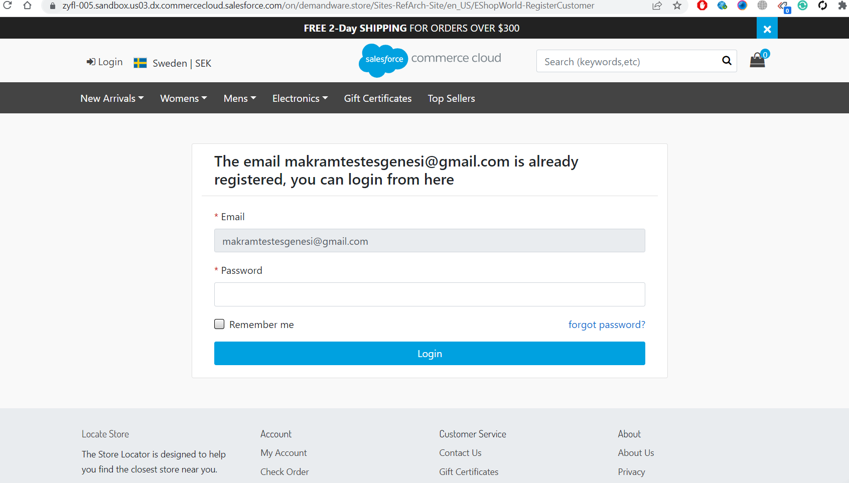
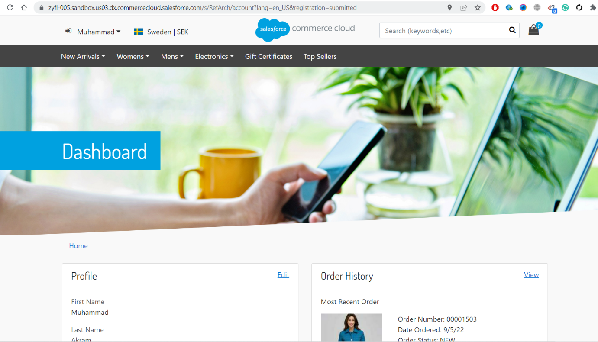
  - Testing Sandbox/Staging Environment
There are two options to test this feature in a sandbox/staging environment.
- Create an order with a new email following the ESW checkout flow. Click create account registration link on the order confirmation page.
- Place an order with the existing account email. Click create account registration link on the order confirmation page.
  - Review that the Registration-Account-URL link exists in the pre-ordered request, as seen in the following screenshot for the next domain.
zyfl-002.sandbox.us01.dx.commercecloud.salesforce.com
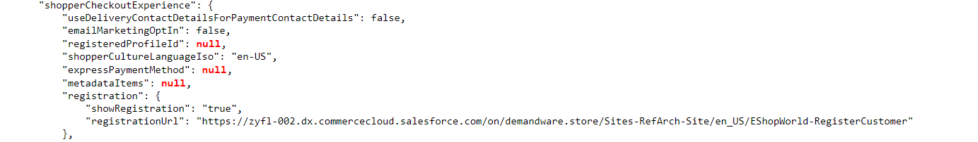
  - Once redirected to the ESW order confirmation page with a new email, click create account link to redirect order history page
  - Once redirected to the ESW order confirmation page with the existing account email, click create account link to redirect to the login form page with the pre-filled email

  - On form submission successfully, customer lands on account and order synced to that newly created account.
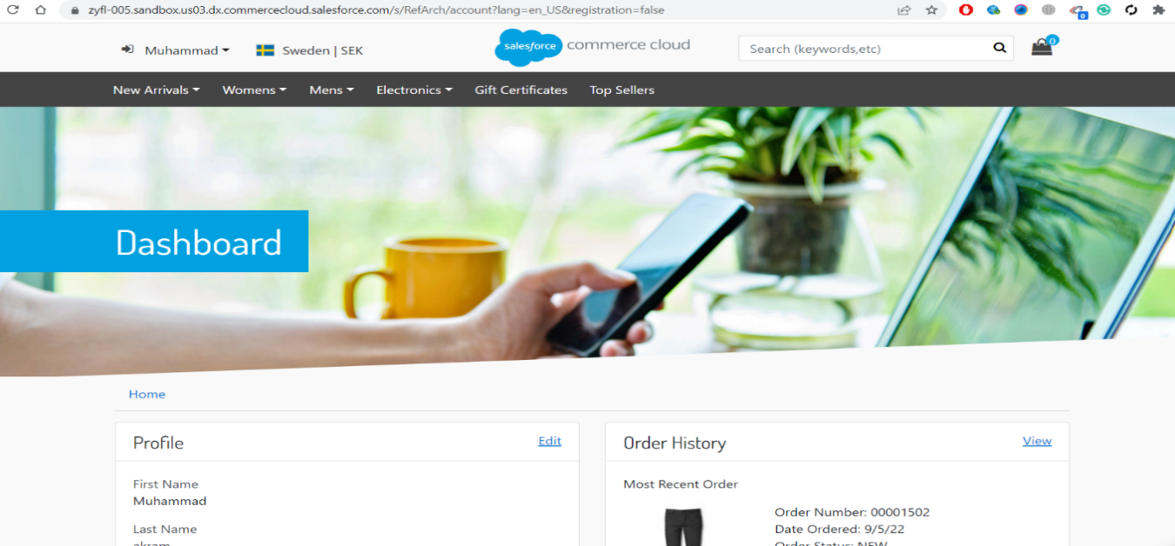

Note:
When the Site Preference for Limit Storefront Order Access is set to Yes, shopper functionality on the PWA after registration will be impacted.
This is because the PWA relies on external access to order details, which is restricted by the OOB SFCC setting that limits external access to orders.

